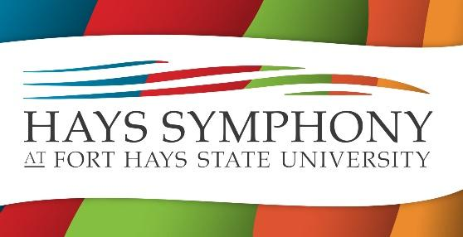

The Hays Symphony is proud to offer all our group’s performances—in the Beach-Schmidt Performing Arts Center, St. Joseph Catholic Church, and Hays Outdoor Pavilion—for free. We can provide this for our community due to the continued support of generous benefactors like you. Please do contact our Symphony Guild Board member below with any questions that you may have with this process, and thank you in advance for considering supporting the longest continually operating orchestra in Kansas.

Symphony Circle
$5,000 and above
Individuals or groups that provide this level of support are considered “Season Sponsors” and are recognized in a variety of ways. Their status is announced from the stage, their name or logo appears in printed programs and other promotional materials, they’re mentioned on radio spots (whenever possible), and their name or logo appears on our website for the entirety of the season.

Concerto Circle
$2,500-$4,999
Individuals or groups that provide this level of support are recognized as “Concert Sponsors.” For one chosen performance during the season, Concerto Circle members are announced from the stage, their name or logo appears in printed programs and other promotional materials, they’re mentioned on radio spots (whenever possible), and their name or logo appears on our website.

Rhapsody Circle
$1,000-$2,499
Individuals or groups that provide this level of support are considered “Reception Sponsors.” For one chosen performance during our season, Concerto Circle members are announced from the stage, their name or logo appears in printed programs and other promotional materials, and their name or logo appears on our website.

The Hays Symphony Guild
PO Box 1591
Hays, KS 67601
https://www.hayssymphony.org/

Dr. M. Brent H. Williams, HSG Board Member
maxbrent@hotmail.com
405-204-5912

The Hays Symphony Guild, an independent non-profit organization [501(c)(3)], has been in operation since 1984. Our EIN is 48-1064670.

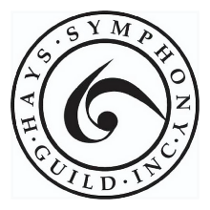

PLEDGE

I/We pledge to make a gift of $_____________.

I/We pledge to make our gift in equal installments of $_________ beginning _____/_____ (month/year)

I/We intend to make payments: ____Monthly ____Quarterly ____Semi-annually ____Annually

CORPORATE MATCHING GIFT

I/We work for _________________________________, a matching gift company.

DONOR(S) INFORMATION

Name:

Address:

Phone:

Email:

Name:

Address:

Phone:

Email:

Signature: _______________________________________________________ Date: _________________

Signature: _______________________________________________________ Date: _________________

Make checks out to Hays Symphony Guild. Visit our website for credit card options.

